**Programming Assignment Template**

**Instructions: Submitting Labs**

Use the following template **for ALL labs**: After adding a new blank .cpp file to your assignment project, paste the template into that file.

TEMPLATE

//<File name> -- brief statement as to the file’s purpose

//CSIS 111-<Section Number> **ADD YOUR SECTION NUMBER**

//<Sources if necessary>

//Include statements #include <iostream> #include <string> using namespace std;

//Global declarations: Constants and type definitions only -- no variables

//Function prototypes int main()

{

//**In cout statement below SUBSTITUTE your name and lab number**

cout << "Your name -- Lab Number" << endl << endl;

//Variable declarations

//Program logic

//Closing program statements system("pause");

return 0;

}

//Function definitions

# Legend:

**//** indicates a comment. It does nothing in the program. It provides instructions to the programmer **#include** is a command that tells the program to include a library of functions to the programmer **int main { }** is the main program procedure. All programming logic and calls between the braces The general format of a program is 1) define variables 2) Program logic (collect data & run calculations) 3) display/store results

**Functions**: Functions are created and defined OUTSIDE the main program. They are called from INSIDE the main program

Don’t worry about the sections of the template you don’t understand yet – they will make sense as we progress through the course.

After pasting in the template, complete the lab coding requirements for the assignment you are working on. **Once you have your lab running,** use the following steps (which will be demonstrated in class) to submit your work:

1. Make a screen shot of the running lab console. (NOT YOUR CODE WINDOW) - See Below
2. Create a Word document. **Paste your screen shot into the Word document** with the title of your lab and your name clearly labeled at the top of the running code window.

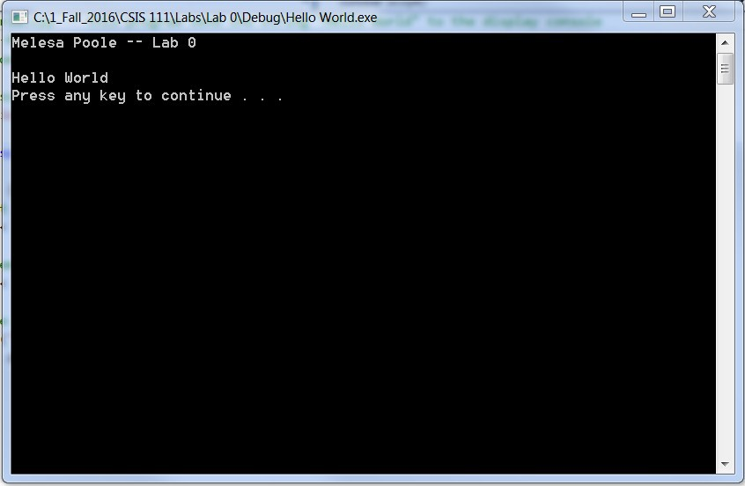

Additionally, below the screen shot you need to assert the following:

* 1. I have not shared the source code in my program with anyone other than my instructor’s approved human sources.
  2. I have not used source code obtained from another student, or any other unauthorized source, either modified or unmodified.
  3. If any source code or documentation used in my program was obtained from another source, such as a text book or course notes, that has been clearly noted with a proper citation in the comments of my program.
  4. I have not knowingly designed this program in such a way as to defeat or interfere with the normal operation of any machine it is graded on or to produce apparently correct results when in fact it does not.

**NOTE:\*\*\*** *Word of warning* – if I find that you have not been true to the four statements above you will lose twice the value of the assignment in points (as a minimum) and receive an academic violation report. But that is minor compared to the loss of your integrity.

1. If you have had some programming in the past and want to use language features in your solutions that we have not covered in class, you must get permission. Assuming I have given you permission you must add the following to the beginning of your Word document:

With {Instructor’s name} permission on (Date Given), I have used the following advanced features in my solution:

1. [Advanced feature 1]
2. [Advanced feature 2]
3. **Save the document in the project directory of the assignment you are working on** Save this file using the following format: firstname_lastname_lab#.doc or docx.

For more information on zipping up your projects , view the “Zipping up your project” presentation by Professor Sipantzi (located in your Labs folder).

1. Zip up the entire lab directory under...\Visual Studio 2019\Projects.

If you need help, **WATCH THIS VIDEO** - <https://www.youtube.com/watch?v=cnpMK6yLwAw>